**Predicting housing prices for real estate companies using Machine Learning or Deep Learning**

1. The database used in this project is Boston Housing database I collected from online sources.

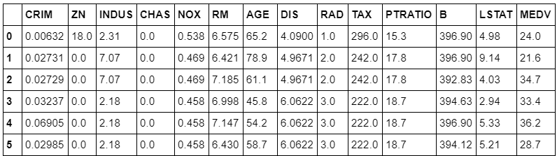

1. the original database has 13 attributes, Shortlisting to 4 main attribute which was: a – Rooms per dwelling (RM)

b – the percentage of population of lower status living in the

area as houses around lower status people are cheap.

(LSTAT)

c - The People-teacher ratio of the place, as education gets to

play a major part in life. (PTRATIO)

d – Median values of homes that is personally inhabitable.

(MEDV)

*( final database file is attached in current folder named as “bostonhousing_datasets.csv” )*

Here the Median value of prices MEDV is the answer to be given by the machine.

1. *Implementation code is attached in this folder with file name “project1.py”.*
2. Proper use of Graphs images and Plotters is used to understand correctly the situation.
3. Graphs of every status of execution and data handling is attached in this project folder in graph folder.
4. Working of the project is attached in file ‘’working.txt’’.
5. Git-hub repository is accessible here:
6. Thank you, this is my first project implementing Machine Learning and I have learnt many things.